Title (Heading 1: Arial bold 20pt)
First Name/s Last Name/s¹, First Name/s Last Name/s² leave blank for anonymous submission
contact.authors@email.mail (separated by comma) leave blank for anonymous submission
¹Affiliation name, Country leave blank for anonymous submission
²Affiliation name, Country leave blank for anonymous submission
(Authors: Arial 10.5pt on 15pt)

Abstract (Heading 2: Arial bold 14pt)
These guidelines provide instructions to format Long and Short paper for ServDes.2023 conference. Please use the formatting styles as instructed. The format described in this document should be used for submissions that will be published in the conference proceedings. As we want to give the proceedings as a publication a consistent, high-quality appearance, we would like to ask authors to follow some simple guidelines. Generally, you should format your paper exactly as this document is formatted. The easiest way to achieve this is to use this template and substitute the content with your own text. This will reduce your work with formatting your submission and reduce the amount of time spent preparing camera-ready submissions. Your abstract should be up to 150 words. (Normal: Arial 12pt on 16pt)
Keywords (Normal: Arial 12pt on 16pt): formatting instruction, template, full papers (maximum 4 keywords)

Introduction (Heading 2: Arial bold 14pt)
All submissions will be blind peer reviewed by an international review panel, according to evaluation criteria set by the scientific committee. Once reviewed, all authors will be notified of acceptance, conditional acceptance, or rejection. Submissions that are accepted conditionally will be required to address the feedback by the camera ready resubmission date (please check important dates at http://www.servdes2023.org). Long Papers that are unfortunately rejected will have the opportunity to re-write and submit as Short Paper.
All submissions must be anonymous and must not contain the name(s) of author(s) or any references of institutions for the purposes of blind peer review. Please ensure these are removed (including file names, captions, etc) prior to upload. You will find the link to access the submission system at http://www.servdes2023.org.
Acceptance of notification will be sent by e-mail. Those accepted will be required to attend and present, discuss questions and engage with the conference program. This means at least one author must register for the conference for the submission to be included in the proceedings. All accepted and revised submissions must be formatted in the ServDes.2023 template and submitted to the conference system (please check important dates at http://www.servdes2023.org)
(Normal: Arial 12pt on 16pt)
Long Papers (Subheading: 12pt on 16pt)
We invite submission of advanced and high-quality papers of up to 6000 words (including abstract, tables, references, and figure captions) that address the conference theme and make a substantive contribution as critiques, theorisation or knowledge production in the service design field, with implications for research and practice. Selection of long papers submissions will be based on the strongest potential for acceptance in indexed journals, in particular, they will be invited to compose a special issue of the Strategic Design Journal - SDRJ.
Short Papers
We invite exploratory, speculative, and/or provocative works of up to 3000 (including abstract, tables, references, and figure captions) words that address the conference theme, including those in progress. The short paper track aims to provide opportunities for lively and respectful discussion.

Formatting your paper submission
The page is A4 (21cm x 29.7cm) and set with a top margin of 3.5 cm, a bottom margin of 3.5 cm, a left margin of 2.5 cm, and a right margin of 2.5 cm.
Footers and headers should not be used for paper-specific text. Never use headings directly under headings, always add text below headings.
Subheading (Subheading: 12pt on 16pt)
Use the subheading style (Subheading: 12pt on 16pt) if another level of heading is required. Use the subheading style (Subheading: 12pt on 16pt) if another level of heading is required. Use the subheading style (Subheading: 12pt on 16pt) if another level of heading is required.

Title and Authors
Multiple row titles should only run over two rows.
In the anonymous submission, leave the placeholders for Authors and affiliation as they appear in this template. When preparing your final submission, all authors should be listed in the author’s row. All authors should fill out contact details (affiliation name and e-mail).

Language and style
The written language of the conference is English. Try using gender-neutral language as much as possible and make sure to explain any culturally specific formulations and be aware not to use ambiguous terms or saying that may be unknown if you are not a native English speaker. Also, try to use a simple and clear style of reasoning and avoid difficult technical terms. Show the full name before you use acronyms the first time.

Lists
- Bullet points (List Paragraph)
- Bullet points (List Paragraph)
- Bullet points (List Paragraph)

Tables
Tables should be formatted as Table 1 (below) and should be created using Word’s table feature rather than an image. Text should be left justified for all columns, if possible. Horizontal table grid lines are preferred. Number tables sequentially starting with Table 1.
For accessibility purposes, it is helpful to mark the header row of each table so that a screen reader or other accessibility software can navigate the table. Highlight the header row or column in the table, click the Table Design tab in the Word ribbon, and check the Header Row and/or First Column checkbox if either contains header information for the table.
Column 1 | Column 2 | Column 3 | Column 4
Second Row | Cell on | Cell four | Cell seven
Third Row | Cell two | Cell five | Cell eight
Fourth Row | Cell three | Cell six | Cell nine

Table 1. Caption for table and credits: (Heading 4: Arial 11pt)

Images

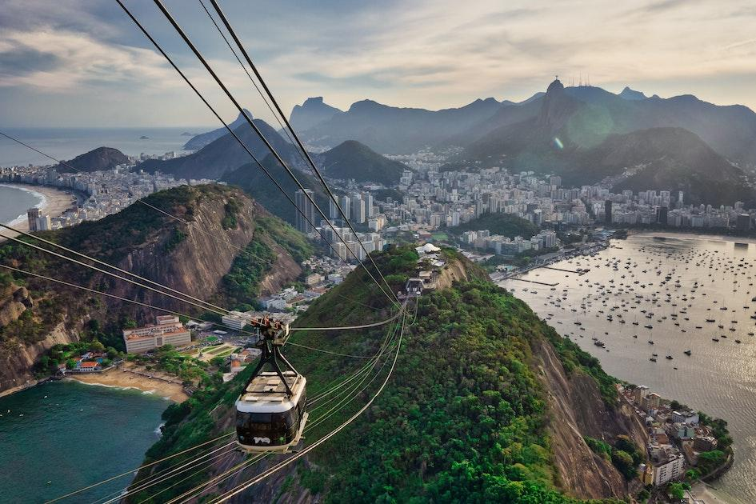

Figure 1. Caption for figures and credits: Photo by Cary Snyder on Unsplash (Heading 4: Arial 11pt)
Images and figures can take up the entire column, in full colour, but not exceed the column width. Please select top and bottom for formatting. Please make sure the images you insert do not exceed 1Mb each. Number images sequentially starting with Figure 1.
For accessibility purposes, add figure descriptions (alternative text) to all figures. For each image in your document, right-click the image and select “Edit Alt Text” and provide a title of the image and a text description of the image. Remember that the text description should include the equivalent information to the image itself so that the content is accessible to readers and reviewers who cannot read the image.

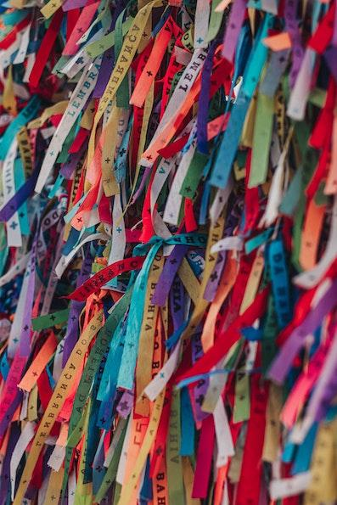

Figure 2. Caption for figures and credits: Photo by Marianna Smiley on Unsplash (Heading 4: Arial 11pt)
Please note that ServDes. Conference submission system only accepts uploads in a PDF format. Still images may be embedded in the pdf. Other types or larger-sized media should be made available online, the URL of which must be included and clearly indicated in your pdf submission. Please make sure that copyright is sought prior to submission, if the images are not your own. If the submission contains images of people, please obtain permission by those to make them public.

References and citations
Citations as part of a sentence shows authors names in text and year within parenthesis: e.g. as stated by Holmlid & Evenson (2007). Citations that are not part of a sentence should be placed inside parenthesis alphabetically: e.g. revealing patterns of human thought (Bechmann, 2010; Holmlid & Evenson, 2007; Howard, 2008) or other phenomena (Participle, 2008). If a reference is authored by one or two individuals, give both names. For three or more authors, name only the first one followed by et al.. Try using only sources you have personally read or make sure it is clear that you are referring to a second hand source.
Quotations should be part of the normal text flow and include page numbers when possible; e.g. “… a crucial dimension to use to increase understanding and the role of prototyping is at what stage in the generic service design process a prototyping method is used.” (Holmlid & Evenson, 2007, p. 6). For quotations longer than three rows (or longer than 40 words), they should be indented in a paragraph of their own (Quote: Arial 11pt):
Beveridge was a 20TH century giant. The vision and strategy he set out in his first 1942 report were supported by political thinkers on the left and right, and by the general public who wanted a new and fairer Britain. Before Beveridge, Britain can be seen as a place of gross inequality, with health care that few could afford or find, schools which looked like those portrayed in a Dickens’ novel, and a society desperately hanging on to its colonial legacy. The post-war welfare state swept all this away in one of the most dramatic social transformations Britain has ever seen. (Participle, 2008, p. 2)

References should be formatted like in the examples below. If the sources are in another language than English, please provide an English translation of the title and source.

Acknowledgments
This section is optional. You can use this section to acknowledge support you have had for your research from colleagues, students’ participation, internal external partners’ contributions or funding bodies, etc. leave blank for anonymous submission

References
Example of references: please use the APA style for referencing. Note that for the review no references to submitting authors should be included.
Book with one author:
King, M. (2000). Wrestling with the angel: A life of Janet Frame. Auckland, New Zealand: Viking.
Conference paper online:
Bochner, S. (1996, November). Mentoring in higher education: Issues to be addressed in developing a mentoring program. Paper presented at the Australian Association for Research in Education Conference, Singapore. Retrieved from http://www.aare.edu.au/96pap/bochs96018.txt
Journal article:
Germann, F., Ebbes, P., & Grewal, R. (2015). The chief marketing officer matters! Journal of Marketing, 79(3), 1-22.

